
COMSATS UNIVERSITY ISLAMABAD, Wah Campus

Lab Report
---------------------------------------------------------------------
MUHAMMAD UMER RAFIQ (FA23-BAI-013)

SUBJECT: Introduction to Computer Vision

Sir: Dr. Jamal Hussain Shah

DATE: 15-Oct-2026

Lab Assignment: Landmark Recognition Using the SIFT Algorithm

1. Objective and Approach
This lab implements a tourism-style landmark recognition system with Python and OpenCV. SIFT keypoints and 128-dimensional descriptors are extracted from a database of reference landmark images. A query image is matched against every reference image using a Brute-Force matcher (Euclidean / L2 distance) with K-nearest-neighbour matching (k = 2) and Lowe's ratio test. A RANSAC homography then verifies the matches geometrically and projects the reference image outline onto the query to localize the landmark.
To avoid classifying on the raw match count alone, a query is accepted only if (i) the number of reliable matches, (ii) the number of RANSAC inliers, (iii) the validity of the projected polygon, and (iv) the margin over the second-best landmark all pass their thresholds. Otherwise the image is rejected as an unknown landmark. The code was run in Google Colab (T4 runtime); SIFT and the Brute-Force matcher run on the CPU.
Parameter | Value | Parameter | Value
Max image side | 800 px | Lowe ratio | 0.75
Max SIFT keypoints | 2000 | RANSAC threshold | 5.0 px
Reference images / landmark | 8 | Min reliable matches | 20
Held-out query images / landmark | 4 | Min RANSAC inliers | 12
Landmarks in database | 6 | Min margin over runner-up | 1.3x

2. Task 1 - Landmark Image Database
The reference images come from the Kaggle "Wonders of the World Image Classification" dataset (12 classes). Six landmarks were placed in the database, each with 8 reference images stored in its own folder (48 images in total). Stonehenge was held out of the database and used only as the "unknown landmark" query class. Query images were taken from photos that are not in the reference set.
Landmark folder | Reference images | Avg. SIFT keypoints / image
Christ the Redeemer | 8 | 938
Colosseum | 8 | 1132
Great Wall of China | 8 | 586
Pyramids of Giza | 8 | 533
Statue of Liberty | 8 | 434
Taj Mahal | 8 | 1081

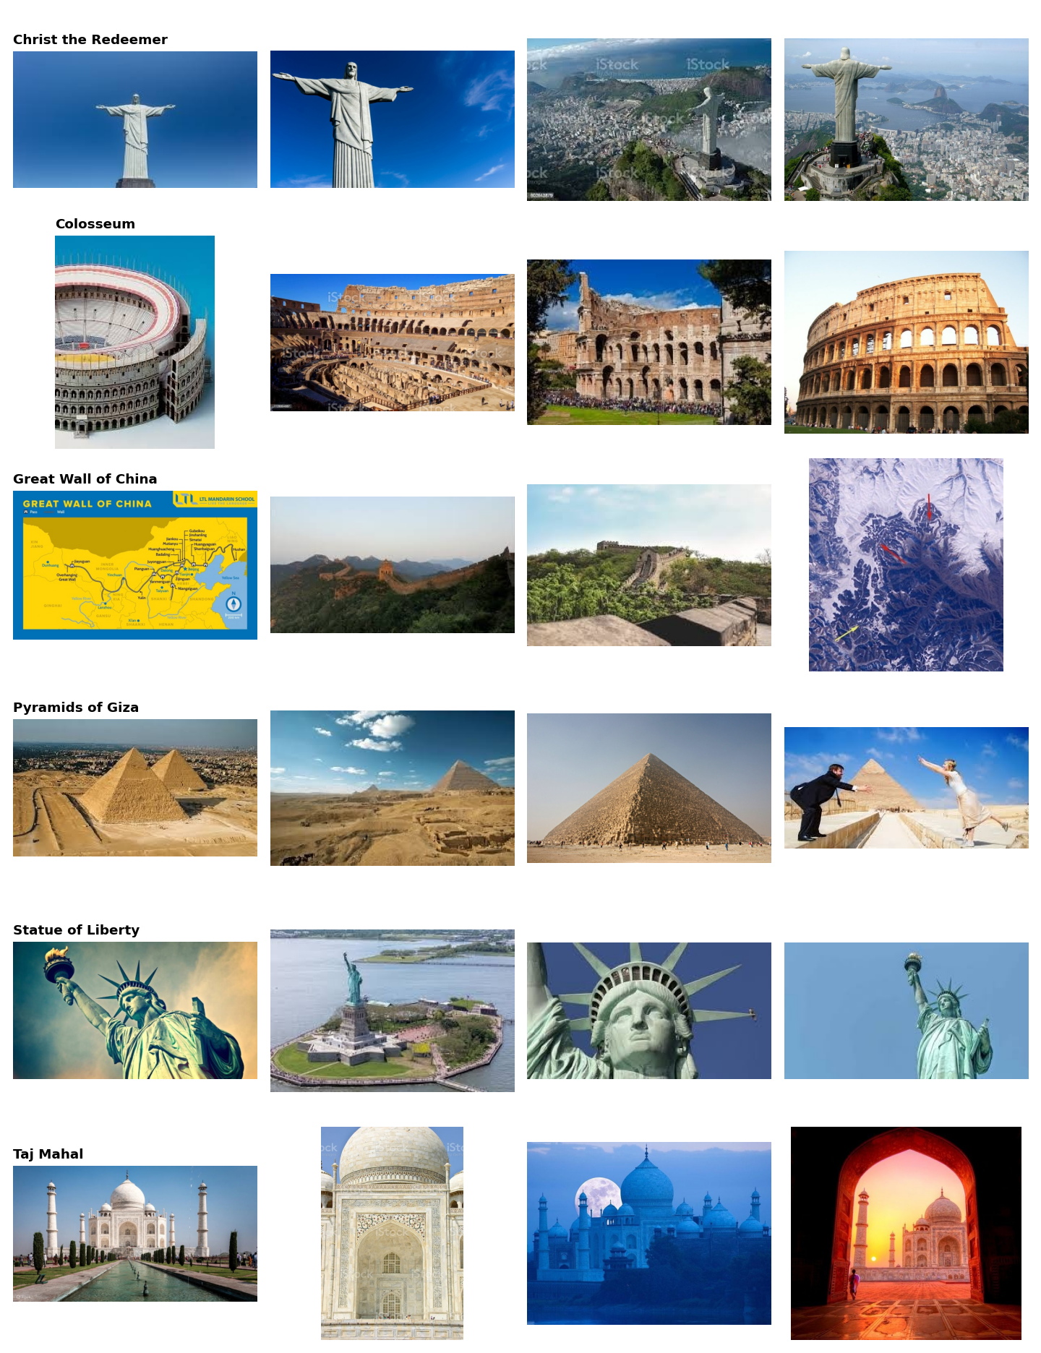
Figure 1: Sample reference images from the landmark database (one row per landmark).

3. Task 2 - SIFT Feature Extraction
Each reference image was resized (longest side at most 800 px), converted to grayscale, and processed with SIFT to obtain keypoints and descriptors. Descriptors were stored together with their landmark labels (pickle file). Extracting all 48 reference images took about 6.2 seconds using multi-threading.
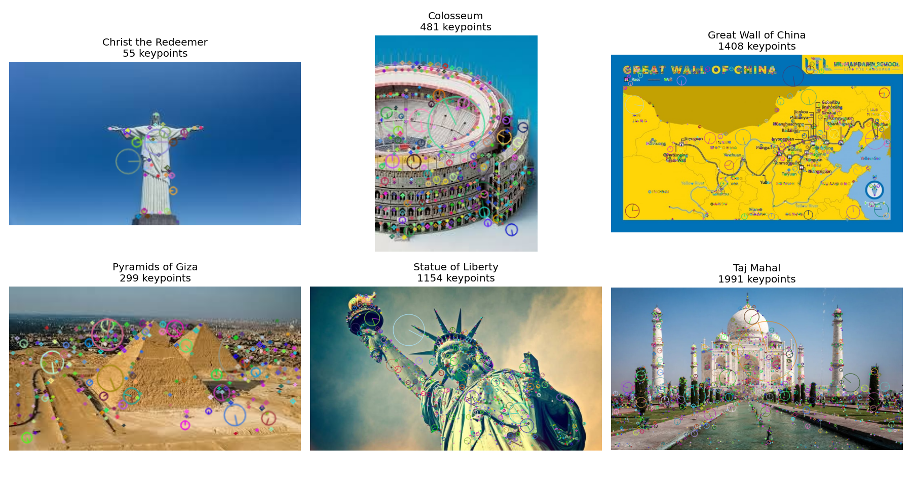
Figure 2: Detected SIFT keypoints on one reference image per landmark (rich keypoints: circle size = scale, line = orientation).
The number of keypoints varies strongly between images, from 55 on a plain sky-background statue photo to almost 2000 on the highly textured Taj Mahal photo. Images with few keypoints give weaker matching evidence later.

4. Tasks 3-5 - Application Output (Screenshots)
Each screenshot shows (1) the query image, (2) its detected SIFT keypoints, and (3) the matches against the best reference image together with the localization result and the final decision. The screenshots below use the Christ the Redeemer query image under each test condition, followed by an unknown landmark.
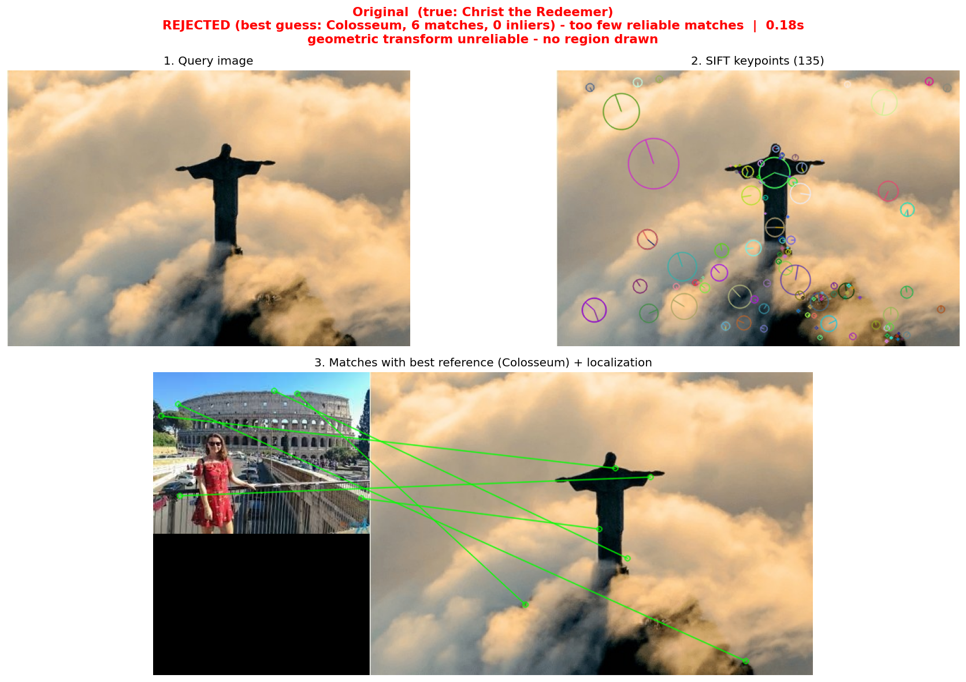
Figure 3: Original query (Christ the Redeemer). Only 135 keypoints on a near-silhouette image; 6 reliable matches, 0 inliers; rejected.
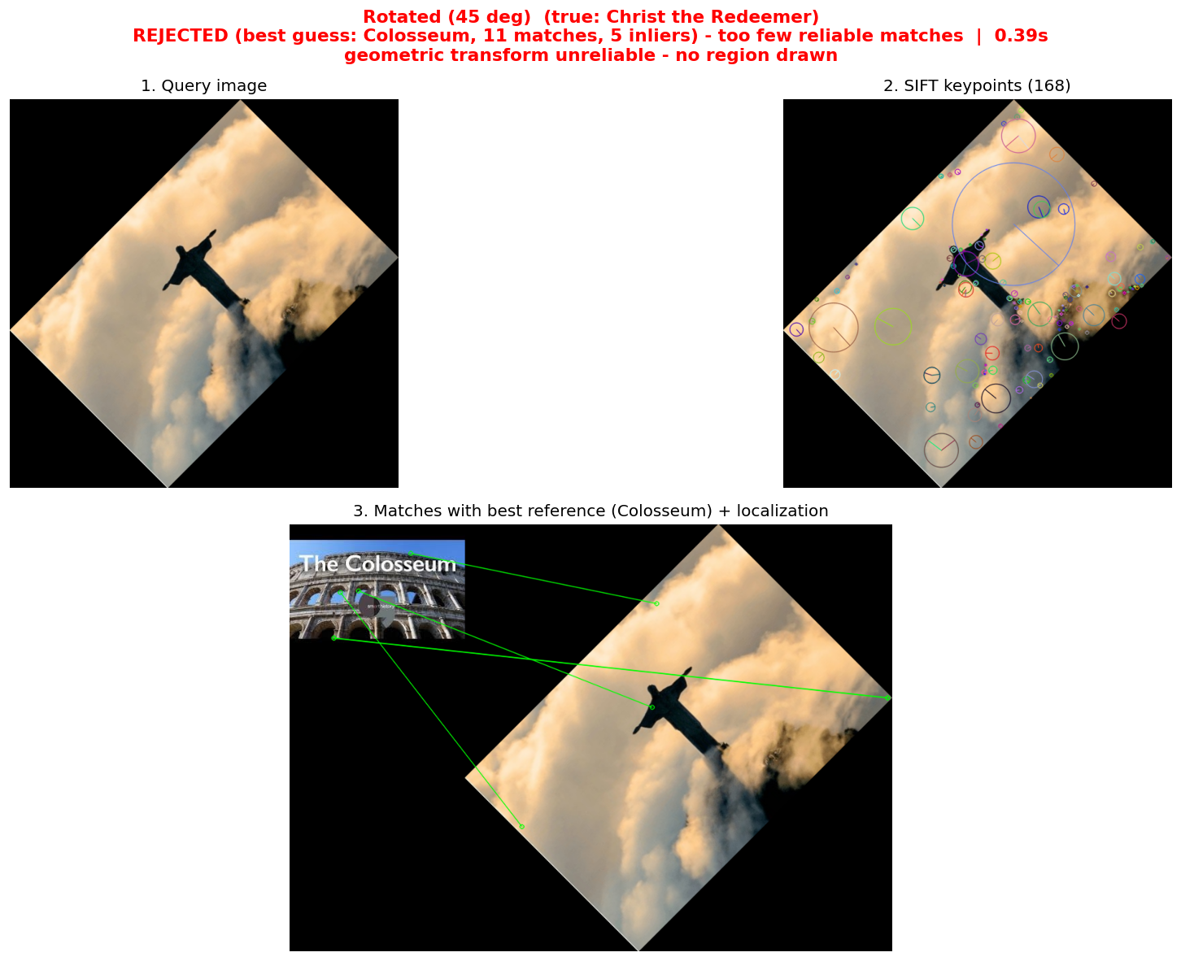
Figure 4: Query rotated by 45 degrees. 168 keypoints, 11 reliable matches, 5 inliers; rejected (too few matches).
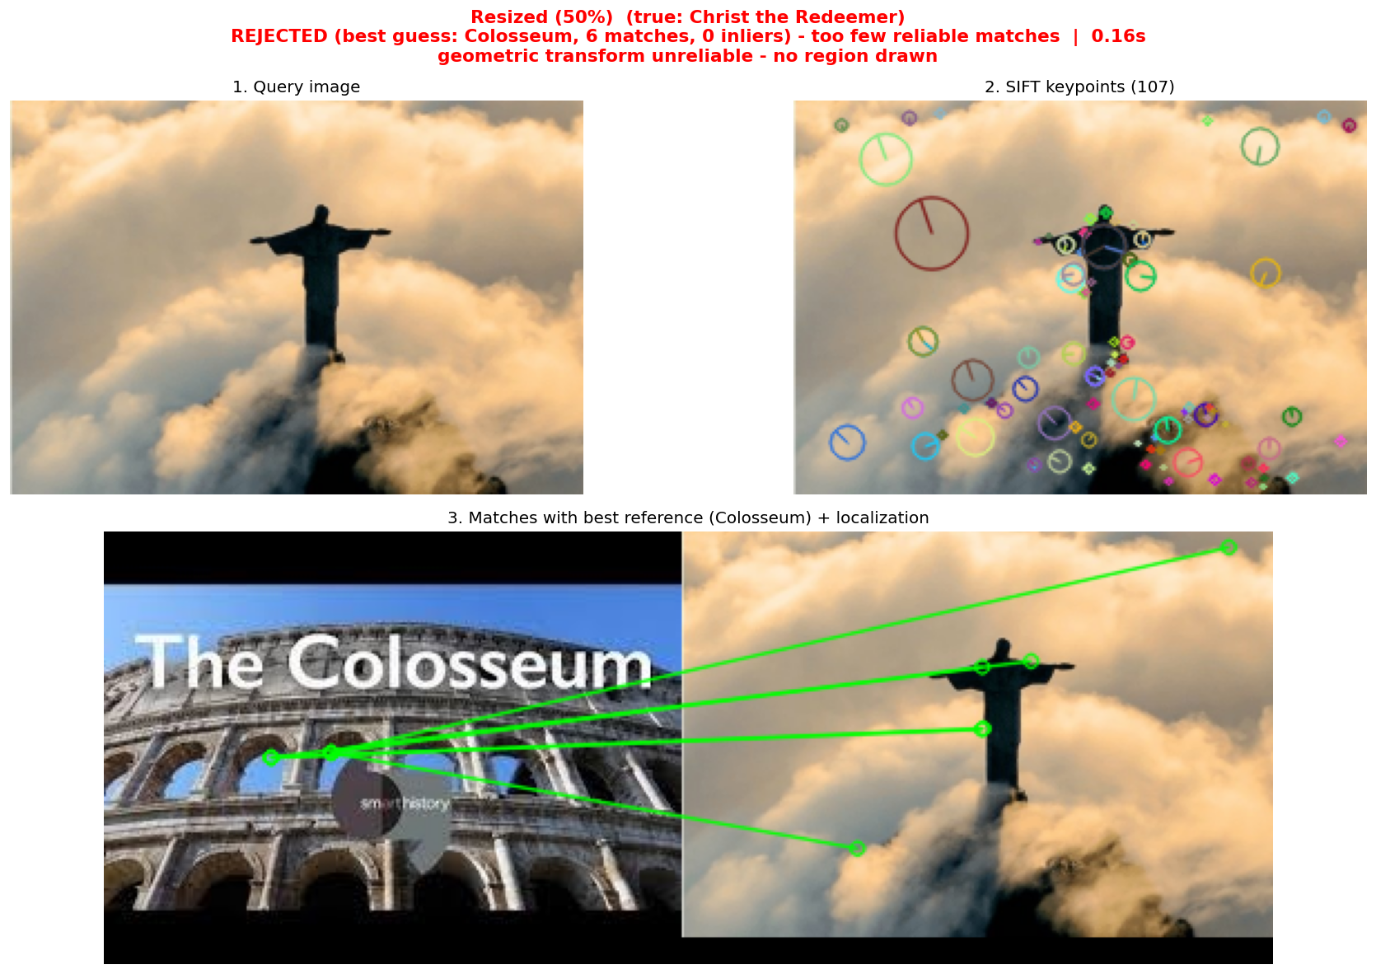
Figure 5: Query resized to 50%. 107 keypoints, 6 reliable matches, 0 inliers; rejected.
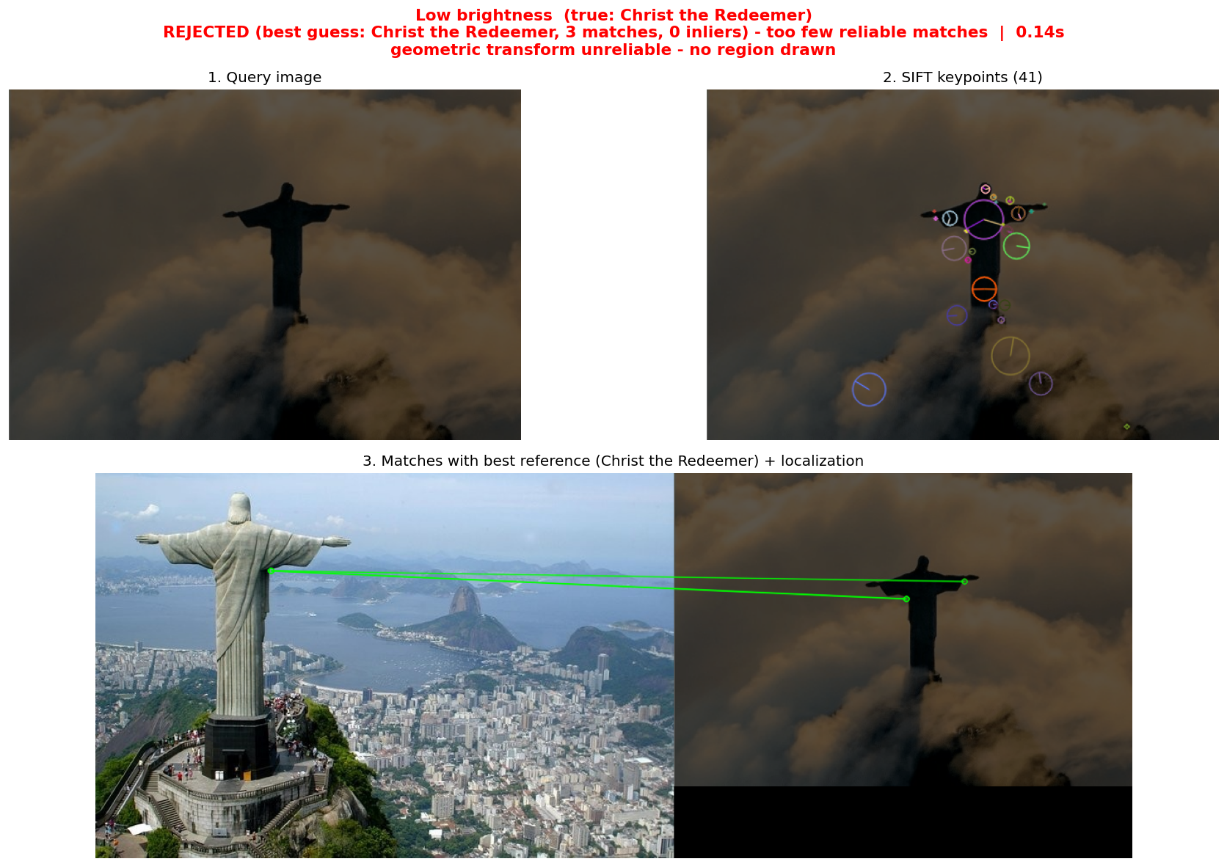
Figure 6: Query with reduced brightness. Only 41 keypoints, 3 reliable matches, 0 inliers; rejected.
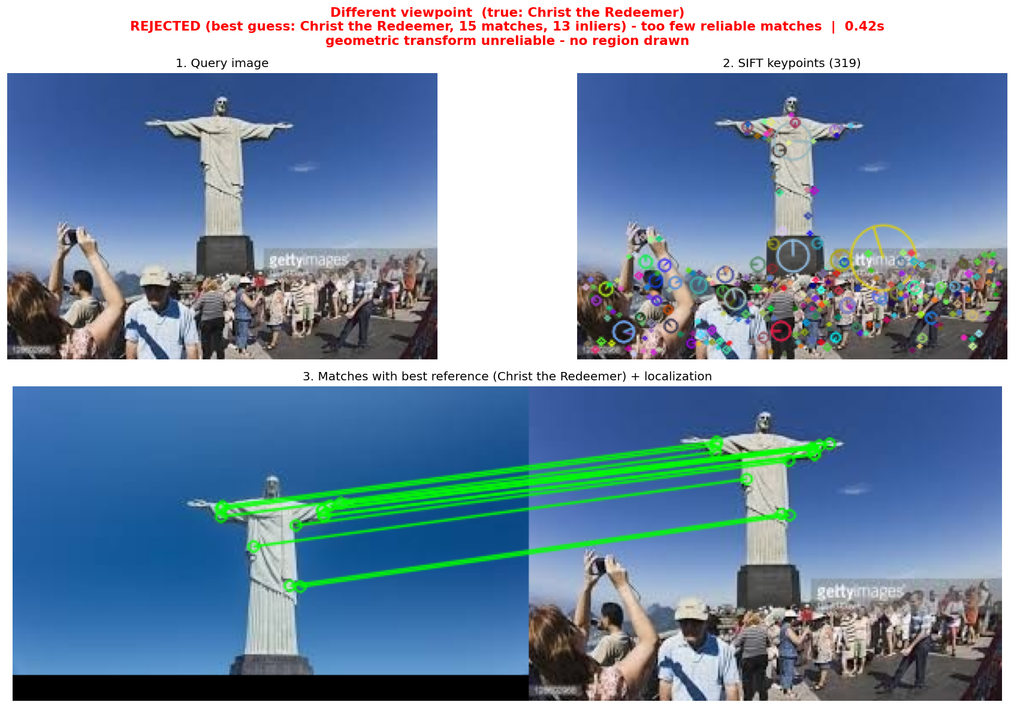
Figure 7: Different viewpoint. The best guess is the correct landmark (15 reliable matches, 13 inliers, all on the statue), but it falls below the 20-match threshold, so no polygon is drawn.
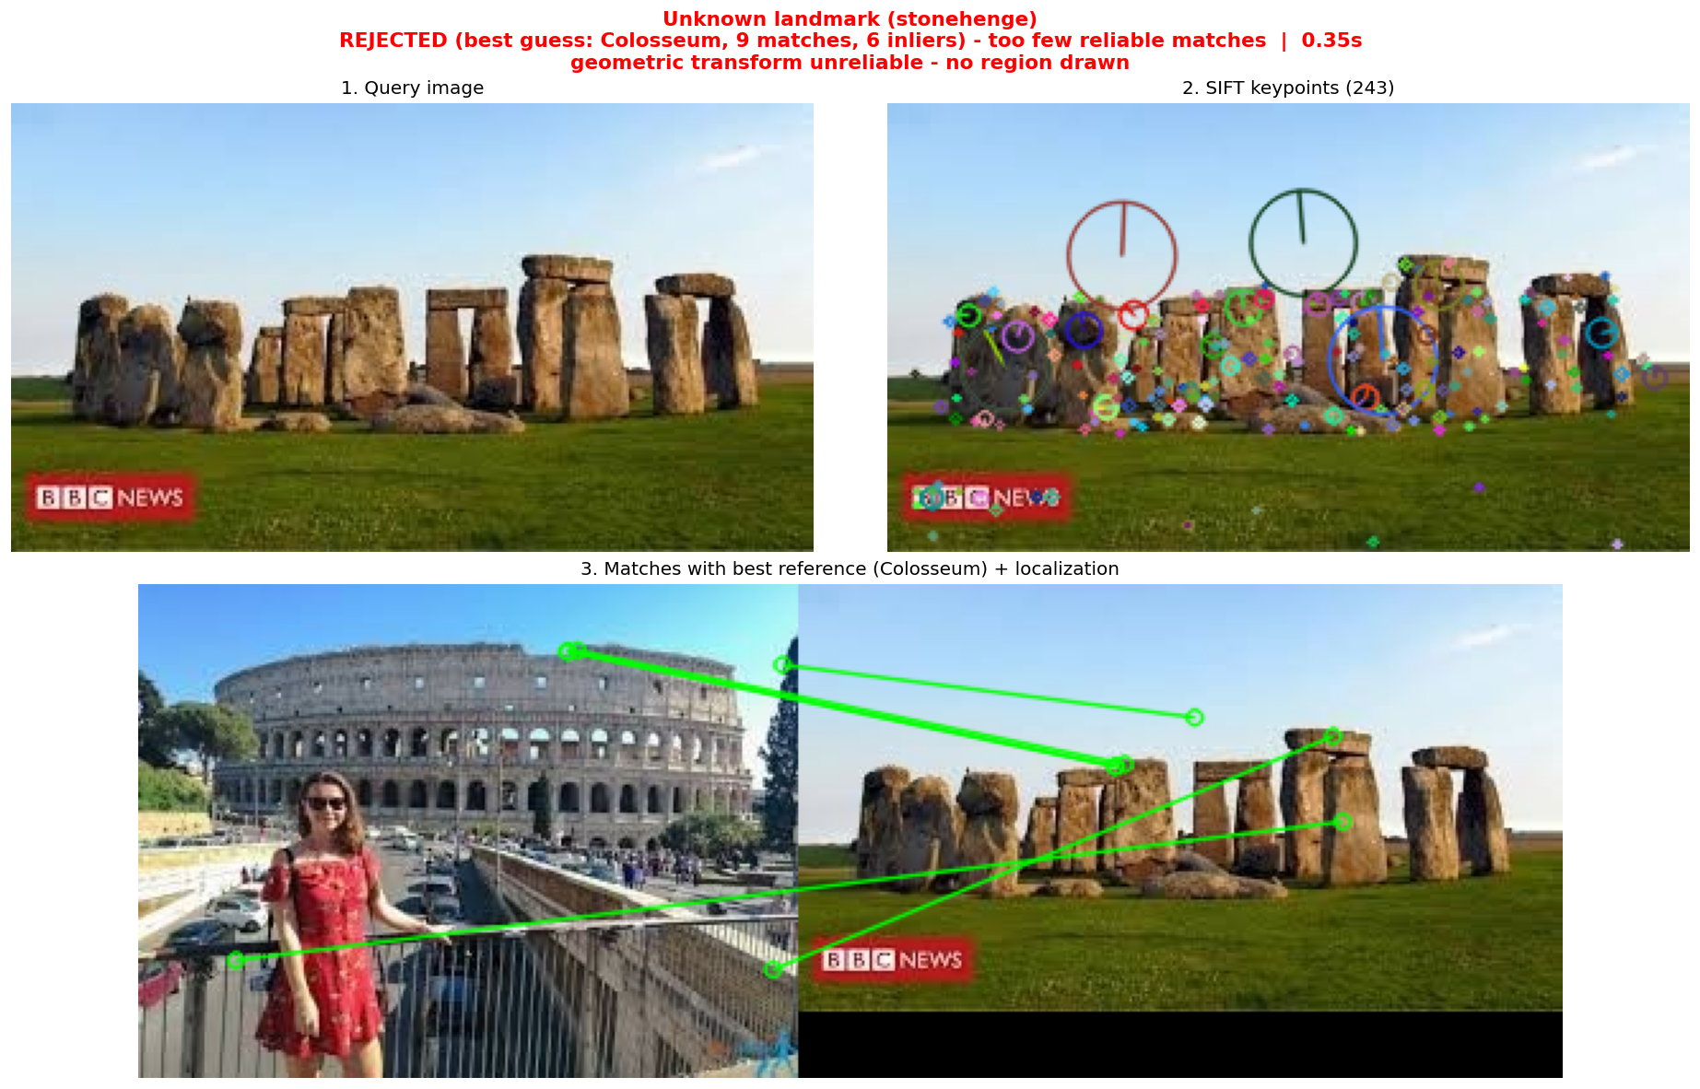
Figure 8: Unknown landmark (Stonehenge, not in the database). 9 matches, 6 inliers; correctly rejected, no polygon drawn.

5. Task 6 - Performance Evaluation
The system was evaluated on 32 queries: the 6 database landmarks x 5 conditions (original, rotated 45 degrees, resized to 50%, brightness reduced, different viewpoint) = 30 queries, plus 2 queries of a landmark that is not in the database. Here "Original" is a held-out photo of the landmark that is not among the reference images. "Different viewpoint" is a second held-out photo of the same landmark. "Correct" means the right landmark was recognized, or an unknown image was rejected.

Table 1: Detailed results for every test
# | True landmark | Condition | Predicted | Key-points | Reliable matches | RANSAC inliers | Decision | Time (s) | Correct
1 | Christ the Redeemer | Original | Unknown (rejected) | 135 | 6 | 0 | Rejected | 0.259 | No
2 | Christ the Redeemer | Rotated (45 deg) | Unknown (rejected) | 168 | 11 | 5 | Rejected | 0.330 | No
3 | Christ the Redeemer | Resized (50%) | Unknown (rejected) | 107 | 6 | 0 | Rejected | 0.122 | No
4 | Christ the Redeemer | Low brightness | Unknown (rejected) | 41 | 3 | 0 | Rejected | 0.080 | No
5 | Christ the Redeemer | Different viewpoint | Unknown (rejected) | 319 | 15 | 13 | Rejected | 0.378 | No
6 | Colosseum | Original | Unknown (rejected) | 541 | 14 | 5 | Rejected | 0.866 | No
7 | Colosseum | Rotated (45 deg) | Unknown (rejected) | 754 | 12 | 7 | Rejected | 1.211 | No
8 | Colosseum | Resized (50%) | Unknown (rejected) | 140 | 8 | 0 | Rejected | 0.184 | No
9 | Colosseum | Low brightness | Unknown (rejected) | 198 | 7 | 0 | Rejected | 0.226 | No
10 | Colosseum | Different viewpoint | Unknown (rejected) | 599 | 10 | 5 | Rejected | 0.675 | No
11 | Great Wall of China | Original | Unknown (rejected) | 326 | 9 | 5 | Rejected | 0.384 | No
12 | Great Wall of China | Rotated (45 deg) | Unknown (rejected) | 444 | 8 | 6 | Rejected | 0.646 | No
13 | Great Wall of China | Resized (50%) | Unknown (rejected) | 102 | 3 | 0 | Rejected | 0.136 | No
14 | Great Wall of China | Low brightness | Unknown (rejected) | 146 | 6 | 0 | Rejected | 0.163 | No
15 | Great Wall of China | Different viewpoint | Unknown (rejected) | 317 | 12 | 5 | Rejected | 0.378 | No
16 | Pyramids of Giza | Original | Unknown (rejected) | 138 | 6 | 0 | Rejected | 0.196 | No
17 | Pyramids of Giza | Rotated (45 deg) | Unknown (rejected) | 205 | 9 | 7 | Rejected | 0.600 | No
18 | Pyramids of Giza | Resized (50%) | Unknown (rejected) | 62 | 4 | 0 | Rejected | 0.141 | No
19 | Pyramids of Giza | Low brightness | Unknown (rejected) | 12 | 2 | 0 | Rejected | 0.044 | No
20 | Pyramids of Giza | Different viewpoint | Unknown (rejected) | 2000 | 26 | 8 | Rejected | 3.291 | No
21 | Statue of Liberty | Original | Unknown (rejected) | 171 | 19 | 16 | Rejected | 0.198 | No
22 | Statue of Liberty | Rotated (45 deg) | Statue of Liberty | 229 | 24 | 16 | Recognized | 0.306 | Yes
23 | Statue of Liberty | Resized (50%) | Unknown (rejected) | 61 | 4 | 0 | Rejected | 0.070 | No
24 | Statue of Liberty | Low brightness | Unknown (rejected) | 56 | 5 | 0 | Rejected | 0.066 | No
25 | Statue of Liberty | Different viewpoint | Unknown (rejected) | 303 | 14 | 7 | Rejected | 0.342 | No
26 | Taj Mahal | Original | Unknown (rejected) | 229 | 9 | 5 | Rejected | 0.253 | No
27 | Taj Mahal | Rotated (45 deg) | Unknown (rejected) | 282 | 19 | 6 | Rejected | 0.384 | No
28 | Taj Mahal | Resized (50%) | Unknown (rejected) | 66 | 5 | 0 | Rejected | 0.071 | No
29 | Taj Mahal | Low brightness | Unknown (rejected) | 50 | 5 | 0 | Rejected | 0.064 | No
30 | Taj Mahal | Different viewpoint | Unknown (rejected) | 484 | 16 | 14 | Rejected | 0.542 | No
31 | stonehenge (unknown) | Unknown landmark #1 | Unknown (rejected) | 243 | 9 | 6 | Rejected | 0.306 | Yes
32 | stonehenge (unknown) | Unknown landmark #2 | Unknown (rejected) | 1652 | 53 | 7 | Rejected | 3.329 | Yes

Table 2: Summary by condition
Condition | Tests | Avg. keypoints | Avg. reliable matches | Avg. RANSAC inliers | Avg. time (s) | Correct
Original | 6 | 257 | 10.5 | 5.2 | 0.36 | 0/6
Rotated (45 deg) | 6 | 347 | 13.8 | 7.8 | 0.58 | 1/6
Resized (50%) | 6 | 90 | 5.0 | 0.0 | 0.12 | 0/6
Low brightness | 6 | 84 | 4.7 | 0.0 | 0.11 | 0/6
Different viewpoint | 6 | 670 | 15.5 | 8.7 | 0.93 | 0/6
Unknown landmark #1 | 1 | 243 | 9.0 | 6.0 | 0.31 | 1/1
Unknown landmark #2 | 1 | 1652 | 53.0 | 7.0 | 3.33 | 1/1
Overall | 32 | 331 | 11.2 | 4.5 | 0.51 | 3/32 (9.4%)

Result: with the thresholds used, 1 of 30 queries of known landmarks were recognized correctly (3.3%), and both unknown-landmark queries were rejected (2/2). Overall accuracy was 3/32 = 9.4%. No known landmark was recognized as a wrong landmark: all 29 misses were rejections (false negatives), and there were no false positives. Processing time ranged from 0.04 s to 3.33 s (mean 0.51 s) and grows with the number of keypoints.

6. Discussion

6.1 Performance
Safe but too strict. The decision rule never produced a false positive: the two unknown Stonehenge images were rejected and no known landmark was labelled as the wrong one. The second unknown image is a good example of why raw match counts are unreliable: it had 53 reliable matches (more than any known-landmark test), yet only 7 RANSAC inliers, so geometric verification correctly rejected it. However, only 1 of 30 known-landmark queries (Statue of Liberty, rotated 45 degrees; 24 matches, 16 inliers) passed all checks, so recall is very low.
Rotation invariance holds. The rotated queries did not do worse than the originals (13.8 vs. 10.5 average reliable matches, 7.8 vs. 5.2 average inliers), which is consistent with SIFT's rotation-invariant descriptors. The small gain is partly because the rotated canvas is larger and contains more keypoints.
Resizing and low brightness failed completely. All 6 resized and all 6 low-brightness queries ended with 0 RANSAC inliers and were rejected. Resizing to 50% removed fine detail (only 61-140 keypoints remained), and reducing brightness removed contrast so that SIFT's contrast threshold discarded most candidates (only 12-198 keypoints).
Viewpoint tests were the closest to success. Different-viewpoint queries had the highest average matches (15.5) and inliers (8.7). For Christ the Redeemer (15 matches, 13 inliers) and Taj Mahal (16 matches, 14 inliers) the geometric evidence was already above the inlier threshold; they were rejected only because the reliable-match count was just under 20. The Statue of Liberty original (19 matches, 16 inliers) was also one match short. This shows that the fixed match threshold, rather than the SIFT matching itself, was the main cause of rejections.

6.2 Limitations
Low-quality, heterogeneous dataset. Many dataset images are small web thumbnails or are not real photographs (for example a map of the Great Wall, a computer-generated Colosseum, and a slide with the text "The Colosseum"). The median number of keypoints in the known-landmark queries was only 184, and 16 of 30 queries had fewer than 200 keypoints. With so few keypoints, reaching 20 reliable matches is difficult even for a correct landmark.
Watermarks, overlays and people. Logos and text (for example the Getty Images watermark or the BBC News logo) and tourists in the foreground generate keypoints that do not belong to the landmark. Some wrong matches in the screenshots connect these regions, and the Original Christ the Redeemer query is almost a silhouette against clouds, which gives very few distinctive features.
Few and uneven reference images. Only 8 reference images per landmark were used, and they differ greatly in viewpoint and quality. A query taken from a different angle may have no reference image that is similar enough. A single homography also assumes a roughly planar scene or a small viewpoint change, which does not hold for 3-D monuments.
Repetitive structures. Arches (Colosseum), bricks (Great Wall) and stone blocks (Pyramids) produce similar local descriptors, which makes the ratio test discard many matches and creates ambiguous matches with other landmarks.
Heuristic thresholds and scalability. The thresholds (20 matches, 12 inliers, 1.3 margin) were chosen without tuning on a validation set. Brute-force matching against every reference image takes time proportional to the database size and to the number of keypoints (up to 3.3 s for 2000-keypoint queries), so it would be slow for a large tourism database.

6.3 Possible Improvements
Lowering the match threshold to about 12-15 while keeping the inlier and margin checks would recover several of the correct near-misses without sacrificing rejection of unknown images. Using more and cleaner reference images (removing maps, drawings and text slides), applying contrast normalization (CLAHE or gamma correction) before SIFT to handle dark images, lowering SIFT's contrast threshold, avoiding downscaling of small images, and using RootSIFT descriptors would all increase the number of reliable matches. For a larger database, an approximate nearest-neighbour index (FLANN) or a bag-of-visual-words shortlist could replace exhaustive matching.

6.4 Conclusion
The implemented pipeline (SIFT, Brute-Force kNN matching, Lowe's ratio test, and RANSAC homography verification) works as designed and reliably avoids false recognitions, including for an unrelated landmark that produced many ambiguous matches. In this experiment, however, the combination of low-resolution, noisy dataset images and conservative thresholds resulted in a low recognition rate (9.4% overall). SIFT matching is therefore suitable for a tourism information system only with higher-quality reference images, contrast and scale handling, and thresholds tuned on a validation set.

